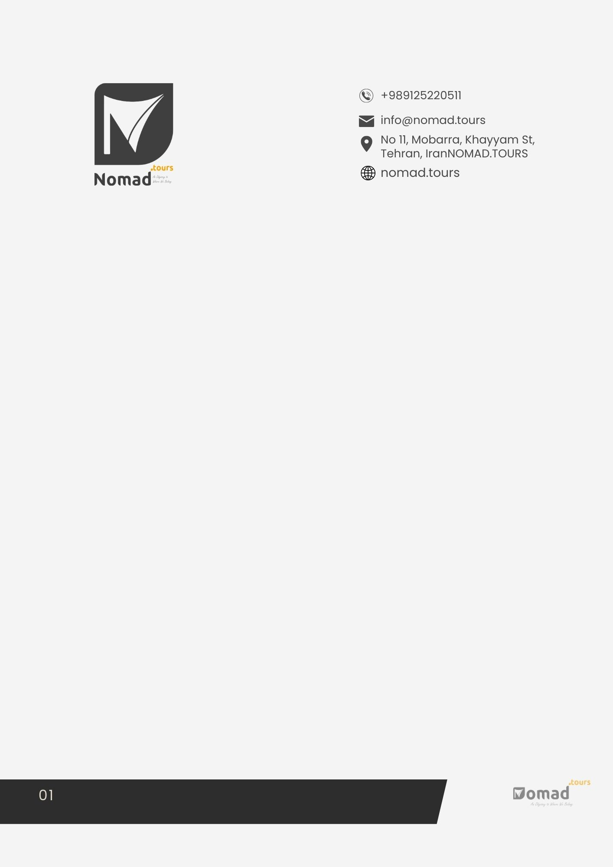

IRAN VISA APPLICATION FORM

For the US, UK and Canadian Passport Holders

IDENTITY & SPECIFICATIONS
- Gender (male/female)
- First Name (As in Passport)
- Middle Name (As in Passport)
- Surname (As in Passport)
- Father’s Full Name (First – Middle – Surname)
- Father’s Nationality
- Place of Birth (City - Country)
- Date of Birth (dd-mmm-yyyy)
- Present Nationality
- Former Nationality
- Marital Status (single/married /divorced/widow/er)
Spouse
- If Married, Nationality of Spouse
- Name (First – Middle – Surname)
- Present Occupation
HOME ADDRESS
15. Country
16.City / State
- Address
18. Telephone (country code – area code – tel No)
19.Cell Phone
20.Zip Code
21.Email
EDUCATION SPECIFICATIONS & OCCUPATION STATUS
Education ( last 10 years)
University  Major |  |  |  |  |  |  |  |  |  |  |  |  | Major |  |  |  |  |  |  |  |  |  |  |  | Date
26.Present Occupation / Present Position in the Working Place
27.Company Name
28.Former Occupation
WORK ADDRESS:
29.Country
30.City / State
31.Address
32.Telephone (country code – area code – tel No)
33.Fax (country code – area code – tel No)
34.Email
Former Occupation (Last 10 years)
Company |  |  |  |  |  |  |  | Position |  |  |  |  |  |  |  |  |  | Date |  |  |  |  |  |  |  |  | Country & city
PASSPORT DATA:
35.Passport Number
36.Issued By
37.Date of Issue (dd-mm-yyyy)
38.Date of Expiry (dd-mm-yyyy)
Notes regarding passport:
- Your passport should be valid for at least 6 months after your return from Iran.
- Please e-mail us a scan or digital photo of your passport (personal details page) in jpg format max 250kb, besides this form
- Your passport cannot contain any stamps of Israel.

Former Travel (Last 10 years)
39.country  country |  | Year
TRAVEL PROGRAM:
40.Type of Visa Required | Tourism ☐ |  | Pilgrimage ☐
 | Official ☐ |  | Journalism ☐
 | Diplomatic ☐ |  | Other ☐
41.Will you be active in journalistic or Scientific activities in Iran?
42.Number of Entries Required | Single ☐ |  | Double ☐
43.Border of Entry
44.Border of Departure
45.Travel Purpose
46.Duration of Stay in Iran
47.Arrival Date in IRAN
(dd-mm-yyyy)
48.Departure Date from IRAN (dd-mm-yyyy)
Note: Keep in mind a medical insurance is required to travel in Iran.

VISA ISSUANCE PLACE:
49.Which Iranian Embassy-Airport Would You Like to Obtain your Visa From?
(Country – City - I.R.I. Embassy)
Additional Questions:
50.List countries you have stayed in for MORE THAN 6 Months
51. Do you have any history of Arrest or Conviction in any country? If Yes, please explain.
52.Have you ever had any contagious disease? If Yes, please explain.
Questions for US, British and Canadian Citizens:
53.Your Flight schedules
- The link for your Social Medias as follows (Instagram, Facebook, Twitter, LinkedIn)
- Your Job/company statement and a short résumé of your previous work(s)
Confirmation:
I UNDERTAKE OF OBSERVE, DURING MY STAY IN THE I.R. OF IRAN, ALL THE LAWS AND REGULATIONS APPLICABLE TO FOREIGN NATIONALS AND I DECLARE THAT THE ABOVE INFORMATION IS TRUE AND CORRECT.
Applicant’s Signature: |  |  |  |  |  |  |  |  |  |  |  |  |  |  |  |  | Date:
Please send this completed form and the following documents for your Iran Visa to: sara.shokouhi@gmail.com

- A scanned photo of the first page of your passport
- A small identical photo with neutral facial expression

